**QUESTION NO 1: Simple Calculator**

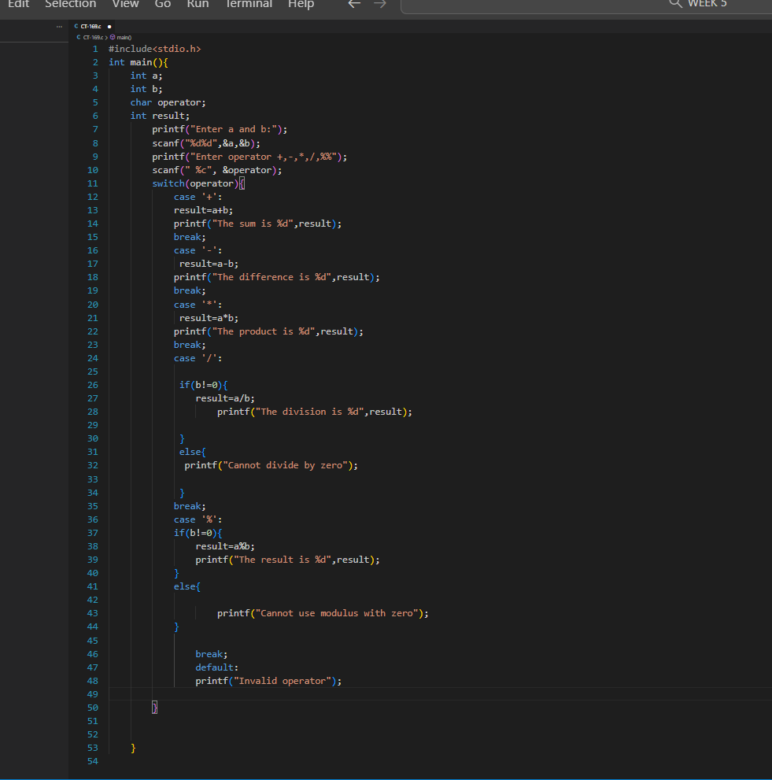

**QUESTION NO 2: College Program and Courses**

